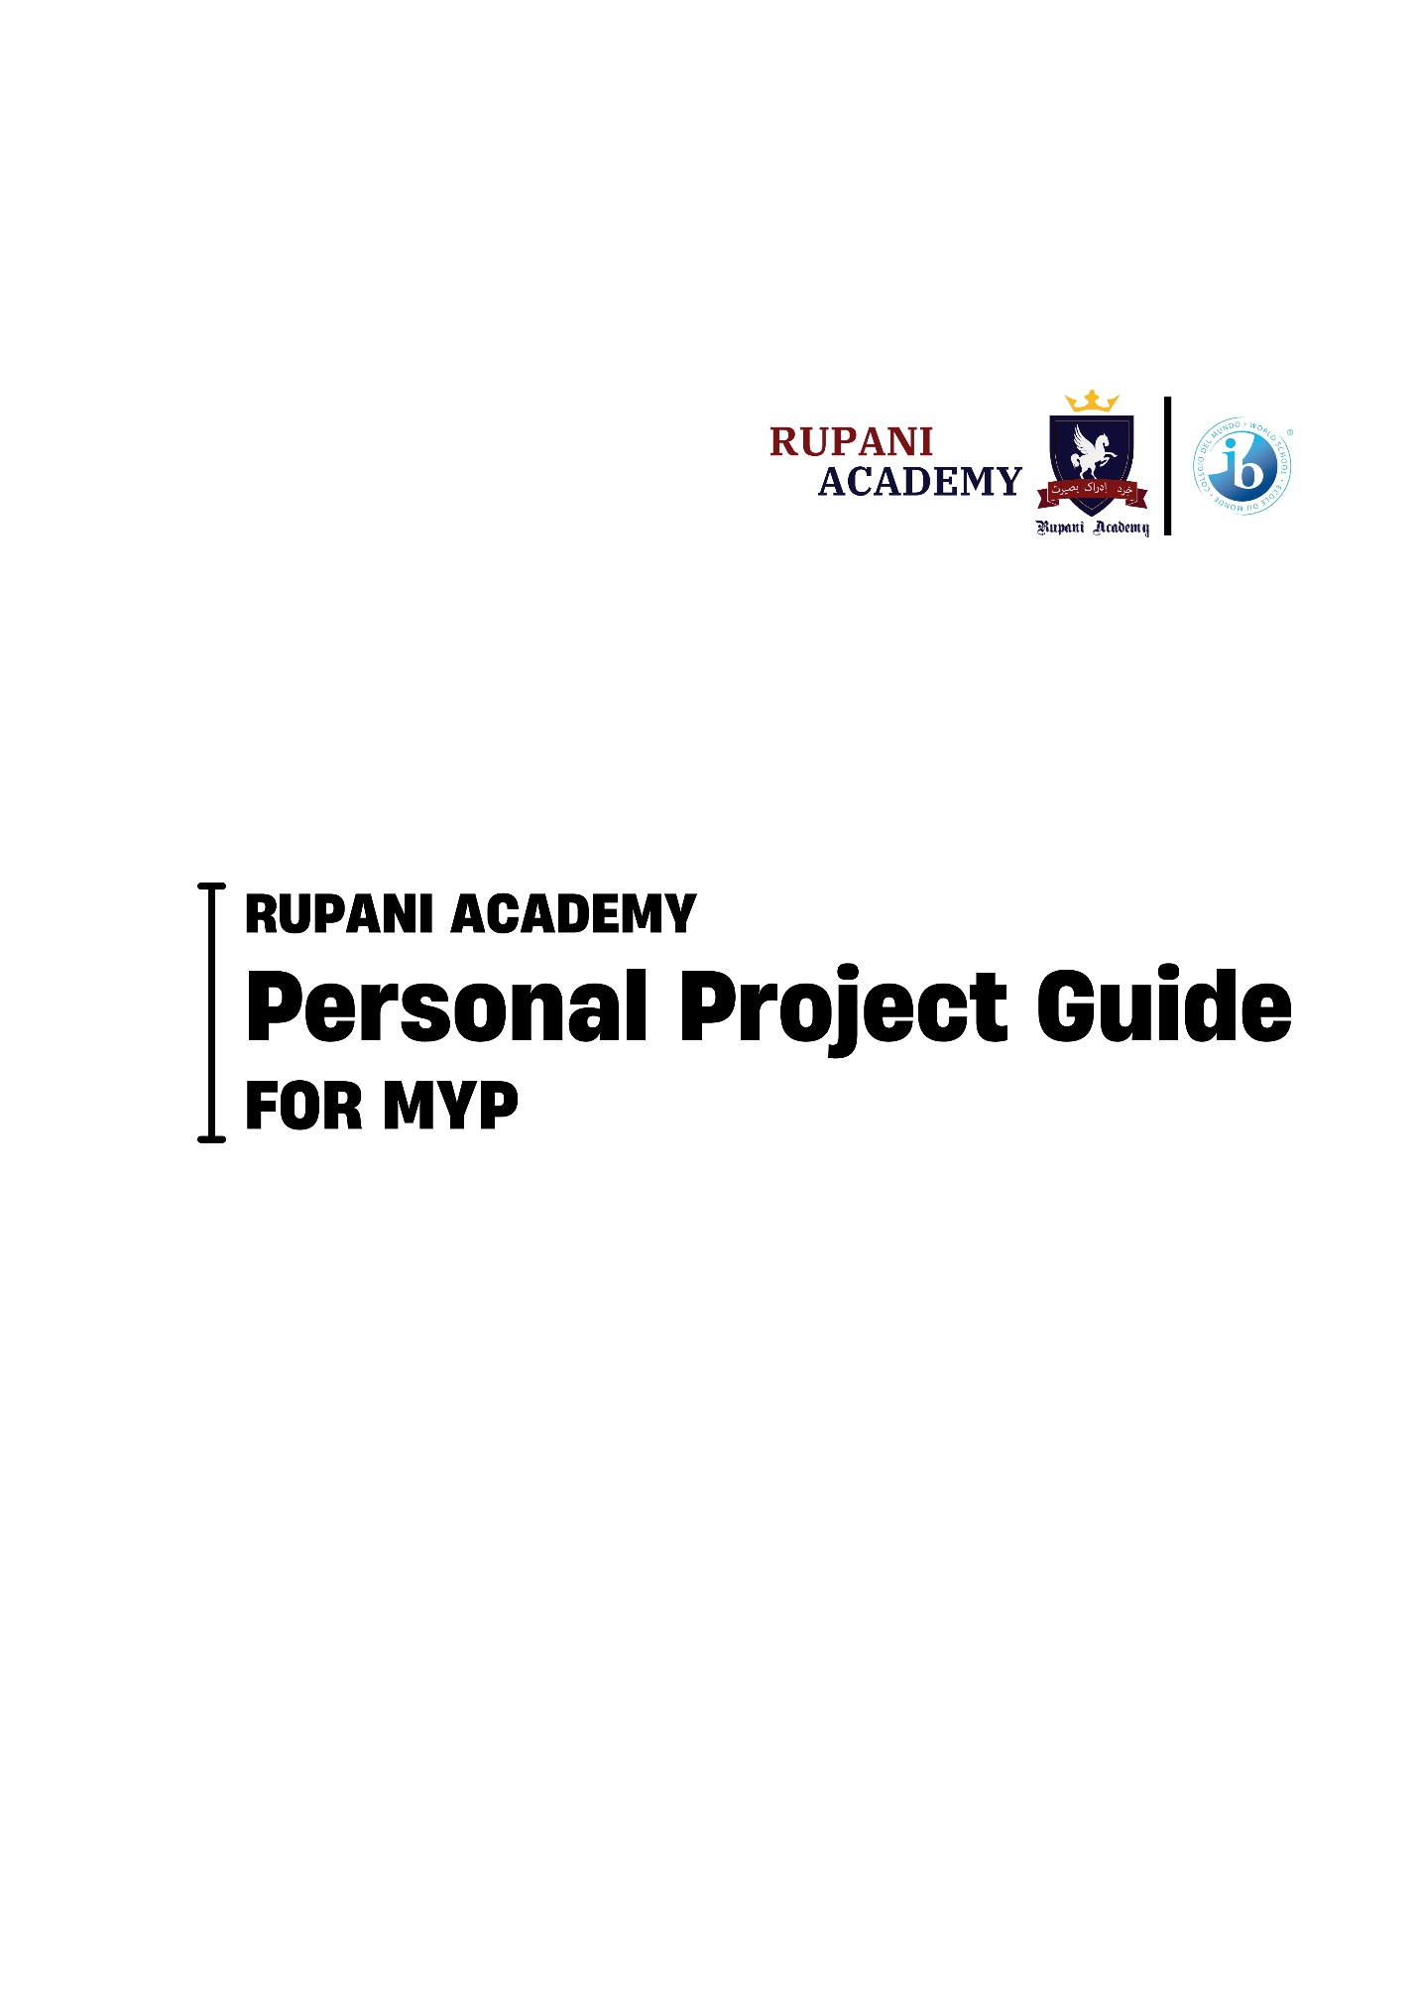
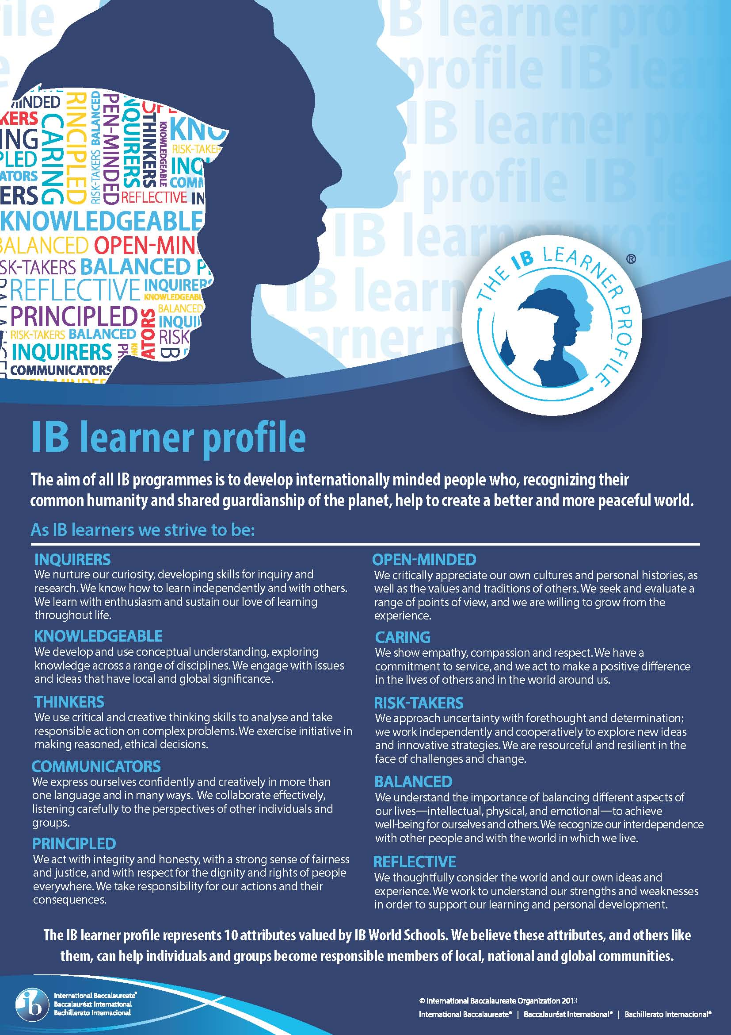

Table of Contents
Nature of The MYP Personal Project ....................................................................................6 Aims.......................................................................................................................................6 objectives……………………………………………………………………………………………………………………… …6 The Role of the Personal Project Coordinator.......................................................................7 The Role of the Student ........................................................................................................7
The Role of the Parents ........................................................................................................8
The Role of the Supervisor ....................................................................................................8 The Role of the library media, or resource center ………….....................................................8
The Role of the Community ………………………………………………………………………………………….….9
Investigating & Planning the Personal Project ......................................................................9
The Project process……………………………………………………………………………………………………………9
The Project Report................................................................................................................15
Assessment……………………………………………………………………………………………………………………...17
Assessment Criteria and Standardization…………………………………………………………………………18
Personal Project coversheet …………………………………………………………………………………………….21
MYP Personal Project Honesty form………………………………………………………………………………….22
Glossary term.........................................................................................................................24
Command term………………………………………………………………………………………………………..………24

RUPANI ACADEMY MISSION STATEMENT
“To provide quality education focusing on life skills and personality development for the upbringing of a generation of productive and contributing global citizens”.
IB MISSION STATEMENT
“Aims to develop inquiring, knowledgeable and caring young people who help to create a better and more peaceful world through intercultural understanding and respect. To this end the organization works with schools, governments and international organizations to develop challenging programmes of international education and rigorous assessment. These programmes encourage students across the world to become active, compassionate and lifelong learners who understand that other people, with their differences, can also be right”.
VISION
A sustainable, educated, and pluralistic society for future generations.

Dear Students, Parents and Supervisors,
This handbook contains information and guidelines for students, mentors, parents and supervisors. We consider that the effective use of this handbook is crucial for students to document their Personal Project fully to maximize their International Baccalaureate Middle year Programme (IB MYP) achievement. Students should keep this book on hand as a resource whenever engaging in activities related to their Personal Project, and particularly when attending meetings with their supervisors
We feel that the Personal Project provides an opportunity for students to explore, research and develop skills in a topic that is their passion which is not directly related to their daily school work and that they may not otherwise attempt.
Personal Project Coordinator: Menail Javed
Co-Coordinator: Zubaida Hassan

What is the personal project?
Students undertake the Personal Project during the final year of their International Baccalaureate Middle Years Programme (IBMYP) as a culminating experience, providing them with the opportunity to demonstrate their acquired knowledge and skills over the five years of the MYP. The assessment of students' Approaches to Learning (ATL) skills, including self-management, research, communication, critical and creative thinking, and collaboration, is formally conducted through the Personal Project. This project comprises a process, a product, and a reflective report.
The Aims of the IB MYP personal project are:



Inquire
Explore an interest that is personally meaningful
Take ownership of the learning by undertaking a self-inquiry

Act

Reflect
Recognise and evidence personal growth and development
Transfer in a place called in for a sort of learning goal and creation of a product

Objectives of the MYP personal project
The objectives of MYP projects encompass the factual, conceptual, procedural and metacognitive dimensions of knowledge. Listed below are the objectives of the personal project specifically. Students should be able to:



Objective B: Applying skills
Objective A: Planning
Objective C: Reflecting
Explain how the Approaches to learning (ATL) skill(s) was/were applied to help achieve their learning goal
Explain the impact of the project on themselves or their learning
State a learning goal for the project and explain how a personal interest led to that goal.

Explain how the ATL
skill(s) was/were applied to help achieve their product.
Evaluate the product based on the success criteria.
Present a clear, detailed plan for achieving the product and its associated success criteria.

STAKEHOLDERS INVOLVED IN THE PROCESS OF PERSONAL PROJECT:
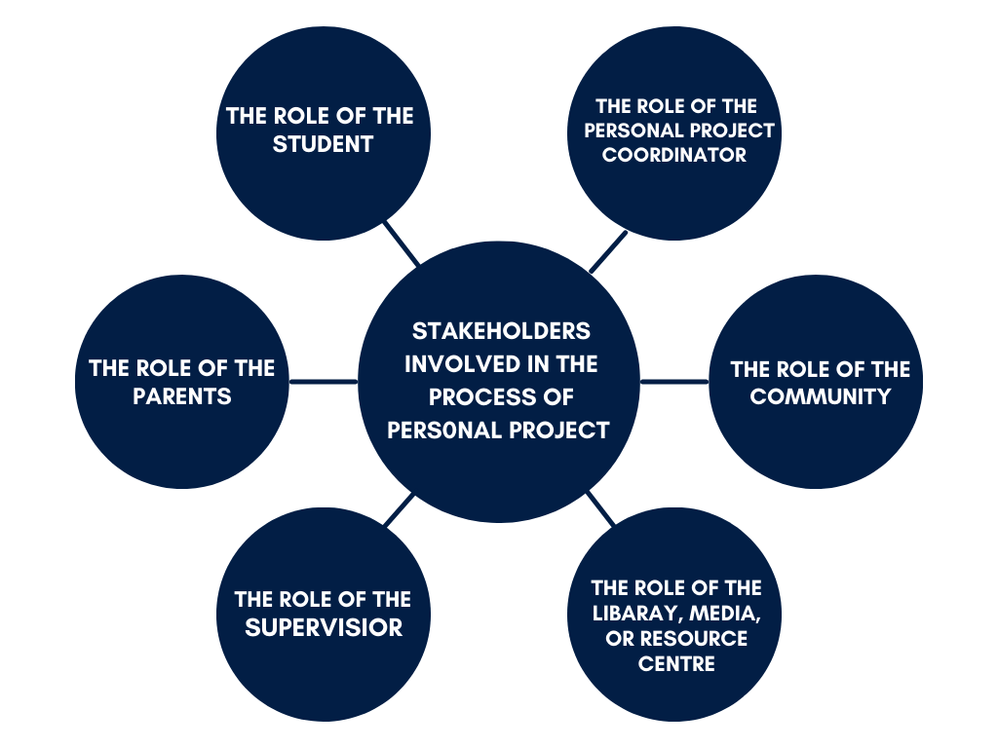
THE ROLE OF THE PERSONAL PROJECT COORDINATOR:
The role of the MYP Personal Project Coordinator involves overseeing and managing the implementation of personal projects within the International Baccalaureate (IB) Middle Years Programme (MYP). This includes coordinating with students, teachers, and possibly external mentors, ensuring proper organization, providing guidance, and assessing the projects in line with the MYP criteria. The coordinator may also handle administrative aspects, such as scheduling, and support students in navigating the personal project process successfully.
THE ROLE OF THE STUDENT:
The aims of the MYP projects are to encourage and enable students to:
- explore an interest that is personally meaningful (intellectual curiosity; family connection; social, cultural or geographical relevance; individual passion; etc)
- take ownership of their learning by undertaking a self-directed inquiry
- transfer and apply skills in pursuit of a learning goal and the creation of a product
- recognize and evidence personal growth and development.
THE ROLE OF THE PARENTS:
Parents play a crucial role in the MYP Personal Project by providing guidance, resources, and encouragement, fostering independent thinking, and assisting with project reflection. By actively engaging in these supportive roles, parents contribute to the overall success and positive learning experience of their children during the MYP Personal Project.
THE ROLE OF SUPERVISIOR:
- Each student has his/her own supervisor who has been allocated by the school.
- Allowing students to approach a supervisor of their choice
- The purpose of the supervisor is to support the student during the project.
4. The supervisor’s responsibilities are to:
• ensure the chosen MYP project topic satisfies appropriate legal and ethical standards with regard to health and safety, confidentiality, human rights, animal welfare and environmental issues
• provide guidance and support to students in the process and completion of the project but not take over the project from the student
• Ensuring students meet the deadlines
• confirm the authenticity of the work submitted
• guidance as necessary
• assessing their work

THE ROLE OF THE LIBARAY, MEDIA, OR RESOURCE CENTRE:
The librarian and the resource specialist will help the learners to develop their information literacy skills by finding and discovering resources to contribute towards the completion of the personal project especially the Bibliography. The librarian can guide students in using library databases, catalog systems, and other research tools. They may also help students develop effective search strategies and evaluate the credibility of sources.

THE ROLE OF THE COMMUNITY:
Students may decide to seek out and use specialists or mentors within the community who facilitate access to research and evidence, provide information to extend skills and knowledge and model good practice. In these cases, the community member guides and supports the students throughout the process.
Investigating & Planning the Personal Project:
The MYP Personal Project consists of three components:
1. Process
2. Product
3. Report
Personal Projects are developed and completed by individual students, but they may involve group work (e.g. a performed play). Students need to identify a goal, based on areas or topics of interest to them. Project supervisors guide and advise students on the selection of topics for the project. Learners are encouraged to record their ideas, document their research process, and track the refinement and development of their initial concepts. They will develop an outline of the goal they wish to pursue, which will form the basis of the first meeting between the student and the supervisor. They should develop a goal that they can accomplish, but which challenges their knowledge, skills or techniques in an appropriate way. Goals should be achievable, based on the time and resources available. The student may involve teachers and other appropriate adults as resources, but students must complete the project independently.
Project process:
1. Setting a Goal:
The goal of the personal project involves two connected elements: a product and a learning goal. Students will create a product, and their learning goal is what they aim to understand or achieve. Some students may start by envisioning a product, while others may commence with a learning goal and then determine the type of product to pursue. The initial learning goal chosen by students has the potential to result in various products, just as a product could align with different learning goals.
Global Contexts:
Global contexts direct learning towards independent and shared inquiry into our common humanity and shared guardianship of the planet. Using the world as the broadest context for learning, MYP projects can develop meaningful explorations of:

• Identities and relationships;
• Orientation in space and time;
• Personal and cultural expression;
• Scientific and technical innovation;
• Globalization and sustainability; and
• Fairness and development.
Students may identify one of these global contexts for their MYP project to establish the relevance of their inquiry (why it matters). The explorations of global contexts in the MYP Personal Project enrich students' learning experiences by providing a meaningful and globally relevant framework for their inquiries. This approach fosters a more comprehensive understanding, encouraging students to become thoughtful, responsible, and globally-minded individuals. Students may consider the following questions as they choose a global context through which to focus their project.
• What do I want to achieve through my Personal Project?
• What do I want others to understand through my work?
• What impact do I want my project to have?
• How can a specific context give greater purpose to my project?
2. Choose your topic
Consider the following questions while thinking about what topic to choose:
- What is something that you have always wanted to learn but have never had the opportunity?
- What problems in our community would you want to solve?
- How do you like to express yourself?
- How and what can you innovate to improve our quality of life or community?
3. Selection of Supervisor
- Choosing a supervisor in the role of a Personal Project Coordinator involves identifying an individual who can effectively guide and support students throughout their project, ensuring a successful and enriching experience.

4. Your personal project plan is the start of your process journal.
- Date every entry.
- Aim for a minimum of one entry per week. Entries include:
- Brainstorming and Thinking Maps.
- Notes, bullet lists, charts, short paragraphs, timelines.
- Annotated research
- Bibliography of resources.
- Notes on what has been learned.

- Annotated illustrations, pictures, photographs, sketches, diagrams.
- Artifacts from inspirational visits to museums, performances, etc...
- Self and peer assessment
- Explanations of how the research was used in the project to reach your goal
- Challenges/difficulties faced
A scrap book may be an effective process journal when:
- evidence is arranged in a logical sequence (this could include collage and mind map work)
- items are annotated
- items are dated to show chronology (order of events).
- objects that reveal the nature of the project are included such as samples of textiles, color swatches
- a variety of materials are used
- it allows the student to effectively communicate the process.

Don’t forget to reflect on your use and development of the Approaches to Learning throughout your process journal

5. Evidence of the Process:
Students are expected to document the process they followed to complete their project. In this way, they can demonstrate how they developed ATL skills and their academic honesty. Possible evidence may include:
● visual thinking diagrams (mind maps)
● bulleted lists
● charts
● short paragraphs
● notes
● timelines, action plans
● annotated illustrations, annotated research
● artifacts from inspirational visits to museums, performances, galleries
● pictures, photographs, sketches
● screenshots of a blog or website
● self- and peer-assessment feedback

Guidelines for collecting evidence of the MYP personal project
Evidence of the process is: | Evidence of the process is not:
- gathered throughout the project to document its development.  - an evolving record of intents, processes, accomplishments.  - a place for evaluating work completed.  - reflection on learning.  - devised by the student in a format that suits his or her needs.  - a record of reflections and formative feedback received.  - a means of exploring ideas and solutions.  - a collection of useful information, for example, quotations, pictures, ideas, photographs.  - a record of selected, annotated and/or edited research and to maintain a bibliography.  - a record of interactions with sources, for example, teachers, supervisors, external contributors.  - a collection of initial thoughts and developments, brainstorming, possible lines of inquiry and further questions raised. | - collected on a daily basis (unless this is useful for the student).  - written up after the process has been completed.  - additional work on top of the project; it is part of and supports the project.  - a diary with detailed writing about what was done (unless this is useful for the student).  - a single, static document with only one format (unless this is useful for the student).

5. Success criteria
The success criteria, developed by the student, measure the degree of excellence to which the product aspires or the terms under which the product can be judged to have been successful.
- The success criteria must be Specific, Measurable, Achievable, Relevant and Time-bound (SMART).
- The success criteria must evaluate the product.
- The success criteria must evaluate the impact on the student or the community

Ideas of specific product features
Product Form: | Product Content:
- technique or material used  - number of pages  - length  - resource people  - visual aspects  - colors  - size  - text type. | - strand  - target audience  - organization  - quality of the language  - result achieved.

6. Action Plan:
Working with the timeline, students plan the time they need to spend on their personal projects by drawing up a timetable that gives them an overall view of everything they have to achieve. They can then add daily or weekly details showing everything they have to do. The action plan must show how students will create the product and fulfill the success criteria. For this step of the project, students may draw inspiration from similar action plans created for the individuals and societies subject. The project is split into three main steps that correspond to the objectives.
- Planning Applying Skills:
- Achieving the learning goal
- Completing the product Reflecting

7. Applying the ATL skills
To complete the project, students must work through different steps to explore the learning goal and achieve the product. Below are some ideas of how to do this.
- Planning resources (financial, human and material) and constraints
- Producing drafts, sketches, prototypes, plans, etc
- Choosing information, techniques and materials based on the research
- Testing techniques and materials
- Compiling a list of purchases
- Predicting other possibilities
- Planning the documents to produce (survey, letter, poster, visual aids, etc)
- Preparing meetings (interviews, surveys, presentations, resource people, etc) Practicing a presentation
- Regularly assessing their work to see if the product helps to achieve the learning goal; this could be a self-assessment or an assessment by another person
- Making necessary improvements
- Presenting the product

Which ATL skills will be useful for your project?
- Review the ATL guide.
- Define the specific skills for each category (communication, collaboration, organization, affective, reflection, information literacy, media literacy, critical thinking, creative thinking, transfer) that you will need.
8. Reflecting
In personal project students should be able to explain the impact of the project on themselves or their learning. Below are ideas to help students assess the impact of their projects.
- What have I learned about the subject?
- What have I learned about myself?
- What skills have I acquired?
- What skills have I improved? What am I most proud of?
- How has my point of view changed? How has my project prepared me for the future?

9. Evaluating the product
Below are ideas to help students evaluate their products based on their chosen success criteria.
- To what extent did I complete my product based on the success criteria?
- How can I demonstrate that I completed my product based on my success criteria?
- What are my project's strengths?
- What could I have done differently to make my product better reflect my success criteria?
Project Report
What is a report?
There are two possible formats for the MYP personal project report: written and oral. Students can combine these formats in a multimedia report. Students may submit their report in written or recorded format, or a combination of the two. The table below shows the maximum length of students’ submissions.
1. To ensure that the written part of the report is clearly legible, each page must have a minimum:
- 12-point font size
- 2 cm margins.
2. Evidence presented in images must be clearly visible at the size submitted.
3. Where a spoken report is submitted, the only evidence that will be considered for assessment is the audio itself, plus any supporting pages of documents.
4. Visual aids (such as PowerPoint slides) may be used to support a spoken presentation, but these will not be considered as a constituent part of the submission for assessment purposes.
5. The bibliography is uploaded separately and is not included in the page limit.
6. Please do not include a title page; if included it will count towards the page limit.

Document File types: .doc, .docx, .pdf (non- editable), .rtf |  | Recording File types: .mp3, .m4a, .mp4, .mov (codec H264), .m4v
15 pages | and | no recording
14 pages | and | 1 minute
13 pages | and | 2 minutes
12 pages | and | 3 minutes
11 pages | and | 4 minutes
10 pages | and | 5 minutes
9 pages | and | 6 minutes
8 pages | and | 7 minutes
7 pages | and | 8 minutes
6 pages | and | 9 minutes
5 pages | and | 10 minutes

Creating a bibliography (MLA)
Rupani Academy has decided to implement the most recent version of the Modern Language Association (MLA) format for academic and research documentation. This decision reflects the school's commitment to staying current with widely accepted standards for citation and formatting in scholarly writing.
What I need for printed material: | What I need for a website:
1. The author’s name | The author’s name
2 The title | The title
3. Where and when it was published | The company or organisation
4. Who published it  5. The number of the edition/volume (if available) | The URL  When you last accessed the page
6. The page number

Assessment:
The IB Personal Project Rubric is available in the appendix. You should use the rubric to understand the performance expectations for your work and to self-assess your project before you submit it. You can earn up to 24 points, 8 points within each of 3 criteria on the IB MYP Personal Project rubric. Once your supervisor has assessed your project using the Personal Project rubrics, your score will be determined based on the following table.
Personal Project Rubric Score | IB Grade
21-24 | 7
18 -20 | 6
15 -17 | 5
12-14 | 4
9-13 | 3
5-8 | 2
1-4 | 1

To be awarded a certificate of completion in the MYP Programme, you must receive a score of 4 or better on your Personal Project.

Assessment Criteria:
 | 1-2 | 3-4 | 5-6 | 7-8
Objective A:  Planning | States a learning goal. | States a learning goal and  outlines the connection  between personal interest(s) and that goal. | States a learning goal  and describes the  connection between personal interest(s) and  that goal. | States a learning goal  and explains the  connection between  personal interest(s) and  that goal.
Objective A:  Planning | States their intended product | States their intended product and presents basic success  criteria for the product. | States their intended  product and presents  multiple appropriate  success criteria for the  product. | States their intended  product and presents  multiple appropriate,  detailed success  criteria for the product.
Objective A:  Planning | Presents a plan that is superficial or that is not  focused on a product. | Presents a plan for  achieving the product and  some of its associated  success criteria. | Presents a detailed plan for achieving the  product and most of its associated success  criteria. | Presents a detailed plan for achieving the  product and all of its  associated success  criteria.
Objective B:  Applying Skills | States which ATL skills were applied to help  achieve their learning  goal. | Outlines which ATL skillswere applied to help achieve  their learning goal, with  superficial examples or  evidence | Describes how the  ATL skills were  applied to help achieve  their learning goal, with reference to examples or evidence | Explains how the ATL skills were applied to  help achieve their  learning goal, supported with detailed examples or evidence
Objective B:  Applying Skills | States which ATL skills were applied to help  achieve their product. | Outlines which ATL skillswere applied to help achieve  their product, with  superficial examples or  evidence. | Describes the impact of the project on themselves or their learning. | Explains how the ATL skills were applied to  help achieve their  product, supported with detailed examples or  evidence.
Objective C:  Reflecting | States the impact of the project on themselves  or their learning | Outlines the impact of the project on themselves or their learning | Describes the impact of the project on themselves or their learning. | Explains the impact of  the project on  themselves or their  learning
Objective C:  Reflecting | Explains the impact of  the project on  themselves or their  learning | Explains the impact of the  project on themselves or  their learning | Evaluates the product  based on the success  criteria, partially  supported with  evidence or examples. | Evaluates the product  based on the success  criteria, partially  supported with  evidence or examples.


PERSONAL PROJECT STANDARDIZATION FORM
Candidate Name:
Criterion | A | B | C | TOTAL/MAXIMUM
Level awarded/maximum
Criterion A: Planning | Explanatory commentary: Referencing the task-specific clarification, what in this work characterizes it as limited, adequate, substantial, or excellent? | Level by Strand
Strand i: state a learning goal for the project and explain how a personal interest led to that goal.
Strand ii: state an intended product and develop appropriate success criteria for the product
Strand iii: present a clear, detailed plan for achieving the product and its associated success criteria.

Criterion B: Applying skill | Explanatory commentary: Referencing the task-specific clarification, what in this work characterizes it as limited, adequate, substantial, or excellent? | Level by Strand
Strand i: explain how the ATL skill(s) was/were applied to help achieve their learning goal.
Strand ii: explain how the ATL skill(s) was/were applied to help achieve their product.

Criterion C: Reflecting | Explanatory commentary: Referencing the task-specific clarification, what in this work characterizes it as limited, adequate, substantial, or excellent? | Level by Strand
Strand i: explain the impact of the project on themselves or their learning.
Strand ii: evaluate the product based on the success criteria.

Deadline to meet with Supervisor and complete Action | Expectations
September 2026 | - Choose the topic.  - Complete the Personal Project Plan form.  - Find a supervisor.  - Brainstorm ideas for the personal project.  - Decide on the format/s you will use for your process  - journal and make necessary arrangements  (Purchasing a scrapbook or setting up a blog to use for your journal entries).  - In your process journal:  - Write a clear learning goal for your Personal Project.  - Reflect on what draws you to this topic and why you are interested in it.  - Write down which Global Context you are considering and why?  - Write down questions you might have for when you meet your supervisor in October.  - Start initial research.
October 2026 | - Begin planning the budget and expenses for your Project.  - Have first meeting of the year with supervisor & record the meeting on the academic honesty form.  - Finalize your project learning goal with your supervisor by choosing a global context and creating a SMART goal.  - Continue your research. Discuss your progress and challenges with your supervisor.  - Continue writing in your process journal.
November 2026 | In your process journal:  - Create a set of questions you need to find answers to when researching your topic and Global Context.  - Brainstorm at least five ideas for people / places/ information sources that you could use for researching your topic and Global Context.  - Using your research questions, begin researching your topic and Global Context. Take notes in your process journal.  - Discuss your progress and challenges with your supervisor.  - Develop your project’s success criteria.  - Develop and begin implementing an action plan for creating/doing your project.
December 2026 | - In your process journal:  - Reflect on what specific information from your research has taught you about your topic and chosen Global Context.  - Reflect on how specific information from your research will help you to achieve your goal.  - In your process journal, reflect on the decisions you will need to make to achieve your goal. Explain how specific information from your research will help you to make these decisions.  - Write down a detailed step-by-step process or plan for achieving your learning goal. Begin working on your product.  - Discuss your progress with your supervisor to make sure that the project is meeting your criteria for success.  - Discuss challenges with your supervisor and work on developing solutions to any obstacles or difficulties.  - Begin creating the draft of your report by doing the Planning section.
January 2027 | - Have a mid-point meeting with your supervisor & record the meeting on the academic honesty form.  - Continue implementing your action plan. Make sure that you are meeting your criteria for success.  - Discuss challenges with your supervisor and work on developing solutions to any obstacles or difficulties.  - Continue writing in your process journal.  - Continue developing the draft of your report.  - Send the draft of the first two sections of your report to your supervisor for feedback.
February 2027 | - Finalize your project.  - Add to your process journal as necessary.  - Continue developing the draft of your report.  - Do the Reflecting section.
March 2027 (Deadline is March 15th) | - Finish developing the draft of your report.  - Send your draft to your supervisor for feedback.  - Finalize your report (by March 15th).  Complete the MYP personal project coversheet.  Have a final meeting with your supervisor& record the meeting on the academic honesty form.  - Develop a way to display and/or present your project at the exhibition.  - Attend the Personal Project Exhibition.

MYP Personal Project Coversheet
Student Name

Student number

School name

School number

Supervisor name

Title of the project:

Learning Goal of the project:

Length (word count and/or presentation time):

Included when submitting the project
- A completed academic honesty form.
- Process journal extracts
- Any supporting visual aids used during the presentation, if applicable
- Bibliography/sources

MYP Personal Project Academic Honesty Form
Student name
Student number
School name
School number
Supervisor name
Student: This document records your progress and the nature of your discussions with your supervisor. You should aim to see your supervisor at least three times: at the start of the process to discuss your initial ideas, then once you have completed a significant amount of your project, and finally once your completed report/presentation has been submitted.
Supervisor: You are asked to have at least three supervision sessions with students, one at the start of the process, an interim meeting and then the final meeting. Other sessions are permitted but do not need to be recorded on this sheet. After each session, students should make a summary of what was discussed and you should sign and date these comments.
Date | Main points discussed |  | Signature
Meeting 1 |  |  | Student:  Supervisor:
Meeting 2 |  |  | Student:  Supervisor:
Meeting 3 |  |  | Student:  Supervisor:
Supervisor comment :
Student declaration:
I confirm that this work is my own and this is the final version. I have acknowledged, in the body of my work, each use of the words, work or ideas of another person, whether written, oral or visual (hard copy and/or electronic materials). Supervisor declaration. I confirm that, to the best of my knowledge, the material submitted is the authentic work of the student.
Supervisor declaration:
I confirm that, to the best of my knowledge, the material submitted is the authentic work of the student.

Student signature: Supervisor signature:

Glossary of Terms
Terms | Definitions
Bibliography | An alphabetical list of every source used to research the project.
Criteria | Specific elements the Personal Project product/outcome must meet to be a quality outcome, as defined by the student.
List of references | An alphabetical list of only those sources that are cited in the project presentation or report.
Outcome | The end result of the student’s Personal Project, used particularly where the project has resulted in a non-tangible result or result that has various aspects to it, for example, an awareness-raising campaign
Outcome | A generic term to refer to the documentation that students develop during the process of completing the MYP project
Product | The end result of the student’s Personal Project used particularly where the project has resulted in a tangible artifact such as a sculpture, film, story or model.

Command Terms:
Terms | Definitions
Create | To evolve from one’s own thought or imagination, as a work or an invention
Define | Give the precise meaning of a word, phrase, concept or physical quantity
Demonstrate | Make clear by reasoning or evidence, illustrating with examples or practical application
Develop | To improve incrementally, elaborate or expand in detail; evolve to a more advanced or effective state.
Formulate | Express precisely and systematically the relevant concept(s) or argument(s).
Identify | Provide an answer from a number of possibilities; recognize and state briefly a distinguishing fact or feature
Justify | Give valid reasons or evidence to support an answer or conclusion
Outline | Give a brief account or summary.
Present | Offer for display, observation, examination or consideration
State | Give a specific name, value or other brief answer without explanation or calculation

